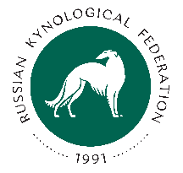
Form №15
RUSSIAN KYNOLOGICAL FEDERATION
www.rkf.org.ru; rkf@rkf.org.ru;

CHANGE OF THE OWNER. APPLICATION

I (name and surname)________________________________________________________________________________

Transfer my dog

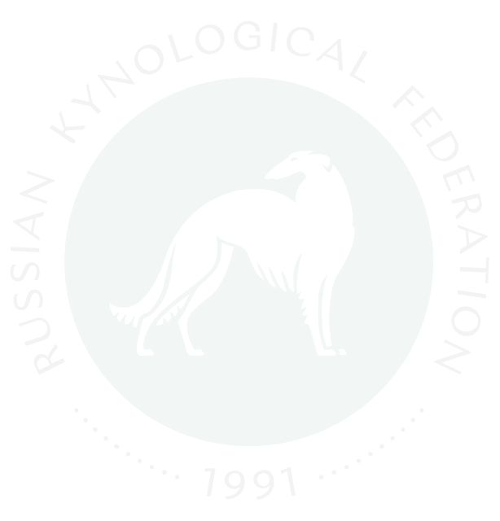
BREED

NAME

BIRTH DATE | TATTOO | COLOUR | SEX
PUPPY CARD № | PEDIGREE №

To (name and surname) _________________________________________

Address _____________________________________________________________________

_______________________________________________________________________________________________________________

E-mail: __________________________________________________________________________

Address and details of the ex-owner:

Name and surname ______________________________________________________________________________________________________

Residence address_____________________________________________________________________________________

_______________________________________________________________________________________________________________

Phone number, e-mail: ______________________________________________________________________

Signature __________________________________

«_______» __________________________202 г. City ____________________________________

CONSENT TO THE PERSONAL DATA PROCESSING

I (the owner) __,
(Name and Surname)
give my consent to the processing of my personal data by the Union of Public Non-profit Cynological Organizations – Russian Kynological Federation (PSRN: 1037700259046). The data is related exclusively to the categories listed below: name, surname; address; mobile phone number; e-mail address.
I give my consent to use the personal data solely for the purpose of maintaining RKF Studbook, the registration of pedigrees of the unified format / extracts from the RKF Studbook – certificates of the origin (hereinafter – RKF pedigree), extracts from the RKF Studbook – registration certificates (hereinafter – RKF registration certificate); champion and other RKF certificates; maintain RKF databases, as well as facilitating the development of Russian cynology and dog breeding in general, promotion and cultivation of responsible dog ownership and care, implementation and promotion of scientific, normative, practical organization of pedigree dog breeding and other activities in the field of cynology, including participation in dog shows and other canine events, representing the canine community at the international level, including collaboration with the Federation Cynologique Internationale (FCI).
This consent is granted to perform actions in relation with my personal data that are necessary to achieve the above mentioned goals, including (without limitation) collection, systematization, accumulation, storage, clarification (update, change), use, transfer to third parties for the implementation of actions to maintain the RKF Studbook, to register RKF pedigrees, RKF registration certificates, championship and other RKF certificates; maintaining RKF databases; depersonalization, blocking, cross-border transfer of personal data, as well as performing any other actions required by the current legislation of the Russian Federation, as well as publication on the website and other Internet resources of Union of Public Non-profit Cynological Organizations – Russian Kynological Federation, Federation Cynologique Internationale (FCI).
I am informed that the Union of Public Non-profit Cynological Organizations – Russian Kynological Federation guarantees the processing of my personal data in accordance with the current legislation of the Russian Federation in both non-automated and automated ways.
This consent is valid until the purposes of personal data processing are achieved or during the period of information storage.
This consent may be revoked at any time upon my written request.
I confirm that by giving such a consent, I am acting of my own free will and in my own interests.

«_____» _____________________ 202 г. ( _____________ )
Signature

